

**NAME:-SYED.MANSOOR BASHA**

**REG.NO:-192111385**

**COURSE.CODE:-CSA1190**

**COURSE.NAME:-OBJECT ORIENTED ANALYSIS AND DESIGN**

**EXPERIMENT-31:-**

**AIM:-** To draw the UML diagrams for AGRICULTURE LOAN MANAGEMENT SYSTEM.

**DESIGNS:-**

**USE-CASE DIAGRAM:-**

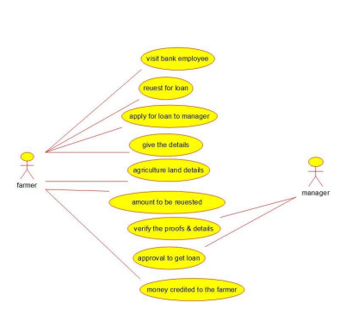

**ACTIVITY DIAGRAM:-**

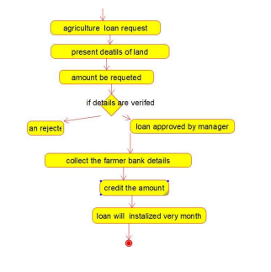

**COMPONENT DIAGRAM:-**

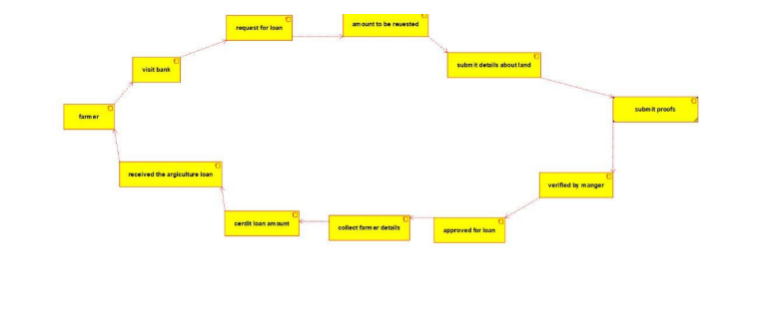

**RESULT:-** Program was Executed Successfully using Umbrello.

**EXPERIMENT-32:-**

**AIM:-** To draw the UML diagrams for JEWEL LOAN MANAGEMENT SYSTEM.

**DESIGNS:-**

**USE-CASE DIAGRAM:-**

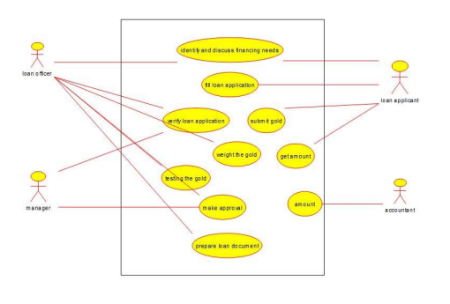

**STATE-CHART DIAGRAM:-**

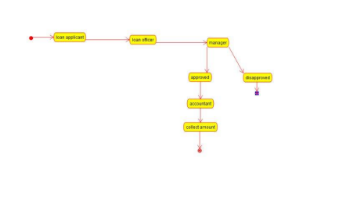

**COLLABORATION DIAGRAM:-**

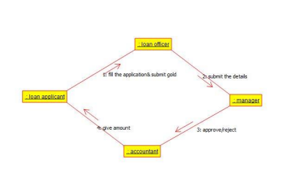

**RESULT:-** Program was Executed Successfully using Umbrello.

**EXPERIMENT-33:-**

**AIM:- :** To draw the uml diagram for personal loan management system using umbrello.

**DESIGNS:-**

**CLASS DIAGRAM:-**

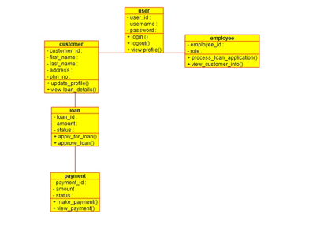

**USE-CASE DIAGRAM:-**

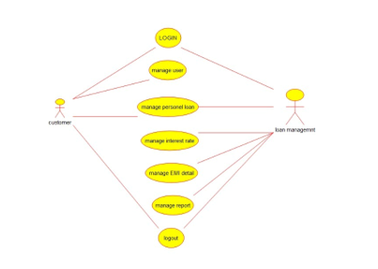

**SEQUENCE DIAGRAM:-**

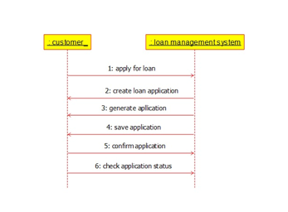

**RESULT:-** Program was Executed Successfully using Umbrello.

**EXPERIMENT-34:-**

**AIM:-** To draw the uml diagram for home loan management system using umbrello.

**DESIGNS:-**

**USE-CASE DIAGRAM:-**

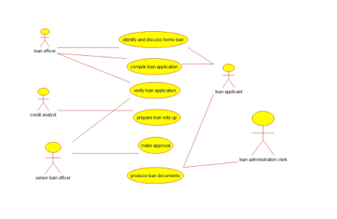

**SEQUENCE DIAGRAM:-**

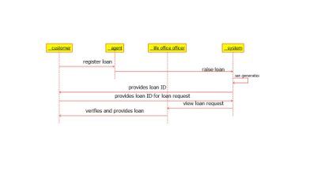

**ACTIVITY DIAGRAM:-**

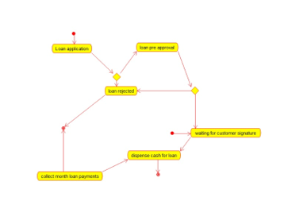

**RESULT:-** Program was Executed Successfully using Umbrello.

**EXPERIMENT-35:-**

**AIM:-** To draw the uml diagram for home loan management system using umbrello.

**DESIGNS:-**

**USE-CASE DIAGRAM:-**

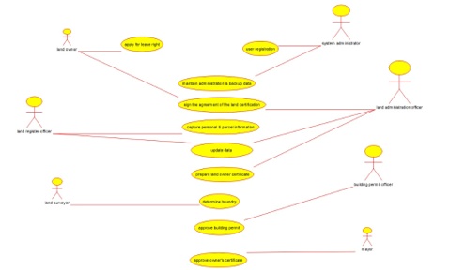

**ACTIVITY DIAGRAM:-**

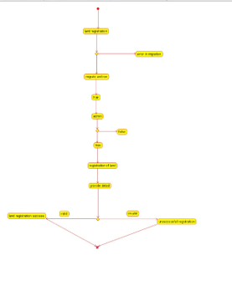

**SEQUENCE DIAGRAM:-**

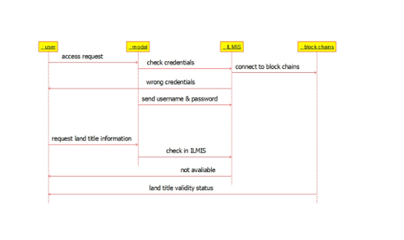

**RESULT:-** Program was Executed Successfully using Umbrello.

**EXPERIMENT-36:-**

**AIM:-** To draw the uml diagram for vehicle booking system using umbrello.

**DESIGNS:-**

**USE-CASE DIAGRAM:-**

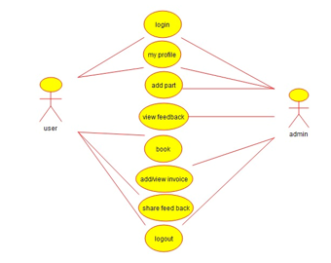

**COMPONENT DIAGRAM:-**

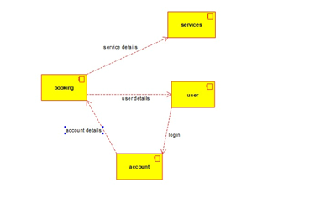

**SEQUENCE DIAGRAM:-**

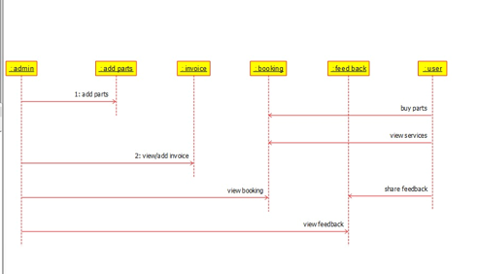

**RESULT:-** Program was Executed Successfully using Umbrello.

**EXPERIMENT-37:-**

**AIM:-** To draw the uml diagram for doctor appointment system using umbrello.

**DESIGNS:**-

**USE-CASE DIAGRAM:-**

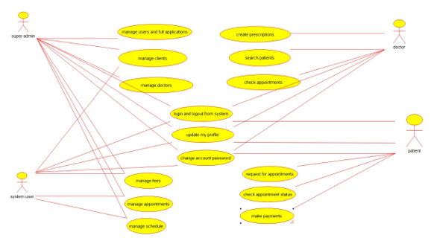

**ACTIVITY DIAGRAM:-**

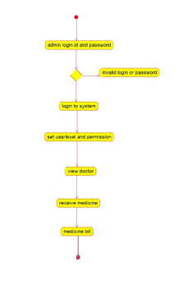

**SEQUENCE DIAGRAM:-**

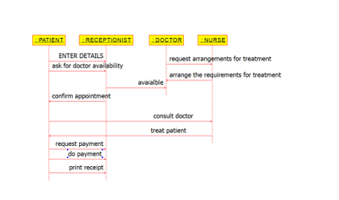

**RESULT:-** Program was Executed Successfully using Umbrello.

**EXPERIMENT-38:-**

**AIM:-** To draw the uml diagram for beauty parlour reservation system using umbrello.

**DESIGNS:-**

**ACTIVITY DIAGRAM:-**

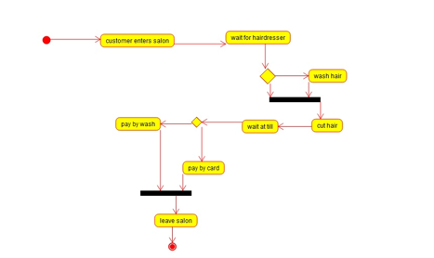

**CLASS DIAGRAM:-**

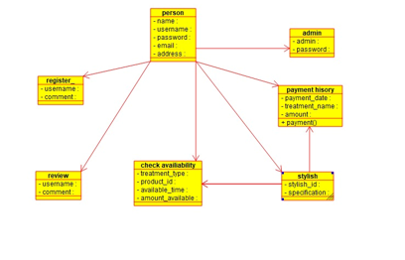

**SEQUENCE DIAGRAM:-**

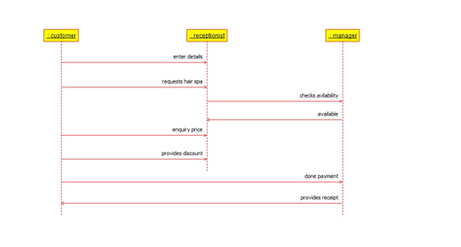

**RESULT:-** Program was Executed Successfully using Umbrello.

**EXPERIMENT-39:-**

**AIM:-** To draw the uml diagram for beauty gardener booking system using umbrello.

**DESIGNS:-**

**USE-CASE DIAGRAM:-**

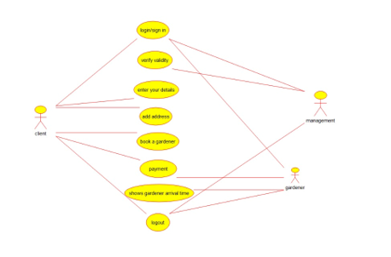

**ACTIVITY DIAGRAM:-**

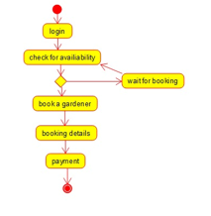

**COMPONENT DIAGRAM:-**

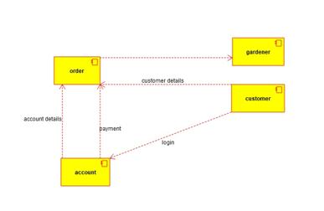

**RESULT:-** Program was Executed Successfully using Umbrello.

**EXPERIMENT-40:-**

**AIM:-** To draw the uml diagram for home tax collection system using umbrello.

**DESIGNS:-**

**USE-CASE DIAGRAM:-**

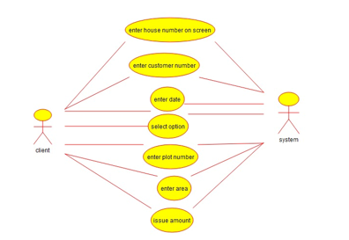

**SEQUENCE DIAGRAM:-**

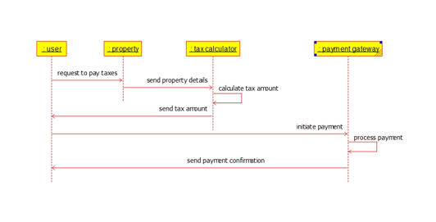

**CLASS DIAGRAM:-**

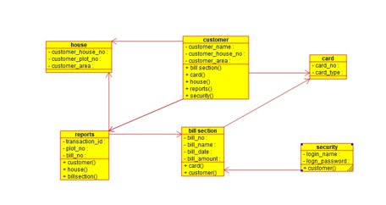

**RESULT:-** Program was Executed Successfully using Umbrello.